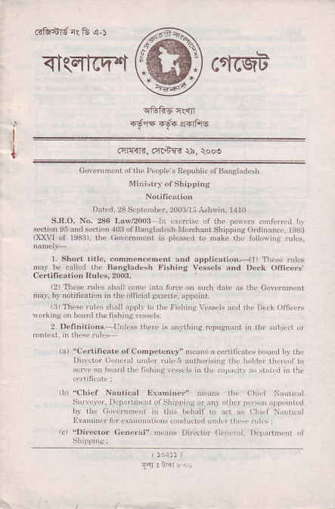
^{<t(qEq.t ctfcqt} ffi
i_{i}.'FRr{, .'rcdm \ir. \ooe
lJtI orr]aosr,dfih
Dxk.l. 2s s.Dr{,1!r. 200i1/1; ;Jrrin, l1r0
^{!r dt} _{P!N!'r} n,r$, rr r,!
hddi ilorlhxntshi ,nlgortinxnco. l93l
^{rL\rI} _{01 r0arr. rrro GovrrnDr.n.} ^{js} _{rc'sd} !) nakc |r ld[onrtr!,!,],s,
^{I rnd lPPricrrion.} lli Thrre r,6
R'nslrdesh Fnhins v.ss.ts
i2)T[!!. ]t r,1s[L] ^{(0n!,} iiio i i
^{p'dn,.} {rooint.
^{an.\hi'rg 'lPtrstrrn i rh.} _{"dli,ri} 0
I th .r )r! r\ r. nrnd i| 1r:
r,rN _{l)ir,anr} iirr.l
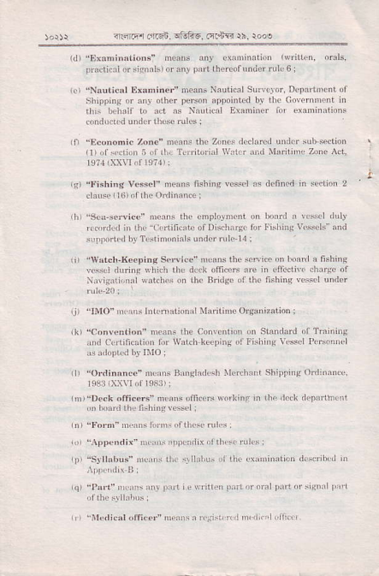
4:.@ .'rr-sn. slif{6..ni6m $. rooe
^{nlr} "Ex.n,nriionJ'
_{0rdirxl} ^{orsiJnak)or an!} _{Dirl} th!r.orrnder n'1.6:
_{f} ^{i} _{"NrurjcRl} Exsn:nci' Dmn: Nxuiicrl Str,roor Dfna'rr!i!dl ^{shippiDs or rrr o1h.r} _{F'\on} rpponncd b| thf CuarDcnr i'i rlir bd,.lr t!) ad 's Nxur!.| Lxa'nird
.on.lrdrd un(lla ih!se !tr1.s:
^{r1,} _{"E.o.o6ic zDnc"} ^{.ans} dr z.o.s dcdlr.d trDd.r \'1, _{ntlior} ' Tu,it,irl \\'.tf i'nl Uaili'n, Zon! Ad.
_{1q)} ^{.!'ish;rg} vess.l n!!ns tishmE vesnt as d.uncd i'r sedioD 2
h _{"sr:i,.se.vi.e" nrc.ns} ^{(hf} onphtD.r' u'
,(rtrdql in rhe Liltiliolcof Dis,hr,!r Jtr!nhiDg!.$oh and
^{L,} _{"v.tcr'xeepins} ^{Srrvicc} _{"n.rN} rho so,\nc on hoa r risbn,B
lrss.l drrinq $hid, ihr dlrk oil
I.,ri{!1irDi'l !rtdns or .hc Br
^{,.ir} _{"!rli)",n,} .I'ndrxtiotr, \hnlimc Oryut.ljo. l
., s.,t _{d} 4 ^{r,.i.} n ;
rd C.Jrifirali,,, liD lt'rr![ k€eDiirF rt fishi,rg \'risd I'(]:.' d ddi rld1i,.rr _{shirdng} (tdrxr(
,tr,i lr.ck olliccfr"n,lns')m.ds No'kin.'r rlx' htk d'J)irthndl
p Srlhhui uerb tlLr.\ lrr,tr" i.l i[..\!Ni'rrii{i dc.oib!, r .rr l'ut ^{!!,N n!} _{r).!i} i ! rfi trr :t,r ^{Di'l} _{ri,l} ^{of r,*f rl} t,i'L
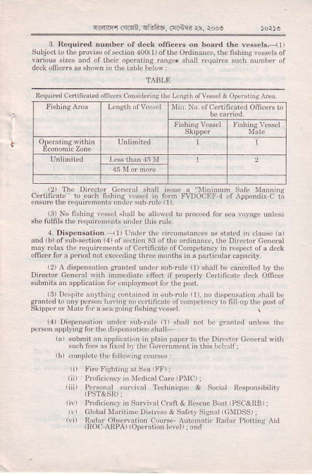
a, nFr ..r.6e. fJlrr. Fq- ii. {n l
_{3. Rcqun.d nun'be. ot d.ck} ^{(,tficeB} on board ,hc vcsscls,:l subjlcr io ^{llrt} Droriso or {dion 100r1rol1be ordi'[n.i. ilf rishinB ^{(iscls} ot .jos rrDg!. straLtuqrn.s nrch nuirbpr of
de.kdm*^ 3r sh0rn ir 1hc ixr,Le [clor:
_l
! ^{.rrinnrm} srri, ^{\lun,ni} c.ii6(rnr n' liirh filhinc flrsfl n Jim FuXr.rnI4 ir ADDedli\ c i
4 ^{Dispcn3a.ion},n s3 0lth! o,din:r.r. rhc Dnad.r cetr.,rl .ffiq for r po inl not .xc! ist
^{L2r r\ dhps'slii!,'} _{srired} trrd.r sub Ntc 1l r sh.li h! .ri.cnd LJ] ih! Dirdor ccnfrrl \lrh ^{iNftiixt! cnld ii} _{r,tupenr} c!,rirj(r!, rrd( atnrcr mrd ri! ^{rtrr} rust.
r3 lr\rnf rrrrlnfq rdoriin{rii.{ l, n,L! rri. u, dnpq,s,ri!n .hrLt br ^{.liiJiulq|1.(il|)!rciq t,fil l} _{I} ^{i|!,} _{DoJ} ol
skiurru rrde rir r s.a:lins rishifs!.s\cl
^{u,l lL} _{f,rrr(lt} trnk.ss rhe
_{I} .... .. ,n. h .tr.5,
rn r Pr)lici!n. i,i $nivrrLr,rr
L\ crr brl rlui'iat rl!,$r & sii.ir _{siFrr} '(;Nlrssrr
Aobmnir llrlr l,li,r!lr* ]\nl
rRoa-,\RP.\rop.nl,Dn kYcl rnd
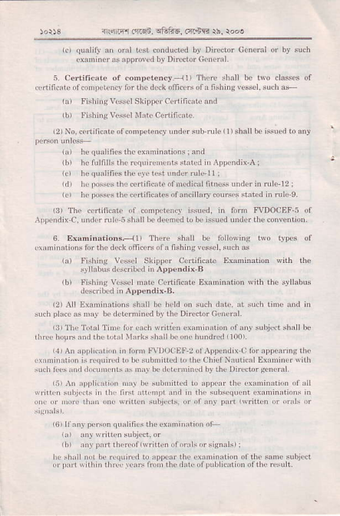
4 5 Fr F4ed. oi\'i.s. rrrts $. roos
ilr qulrjri _{i,} ^{qjr} !r dDdtrd
.qti{i.at.ol..n,p!tunq lor d,c d.ck ofi.ur ofr fin,t,s velscl, sud' !F
L l.iJhiDc!i"nr \lir cedililrk
r2rNo !iificarcff onFirn{\,
_{tI hf} qurlirif\lhrerrnldx'nmii.ntl
ldr herrDss!srhirutiJirxleif drcrllinr.i.urdcrn'nne 12r
of.onl1(n.r i.nHl.
.\,!fndix C rndo n,lc-i sbi'lll)(
6 Exrnimtions. _{llr} ^{'lh?'f} shrLl b. li'Ll$!lns trv, t)D!s of !rrnnnxiioni lof thc dc.r om($ ofr fishins vcsnt,5!'dr.s
r.) !'ir[ing V!-$,1 SkipDr a]q ficnt
^{rbr} fishinr Vcss!l rnrtc Ccltificntc Exarninatioi *lih th',.r!ll!bis
rc hrld on surh drt.. rt s{h tlNc rrl i'l
{rb plr( xs ux} bcd.tN cd
lilT[!Tdx|Tjd|lil.ldry'tr1(
rirr ho!r! aNrrhc rd,,r\trrii I
,1r r\D rp) '.ir o, 'i l.'n |\'l!)
i Lmirrrrion n 'r!tri,i '! l{ s'l
,,, rim n,r,i!(s i 1r riri rr! | i xn.r i,i rhr r,r^
!' frn s,li,!rs.0
,' rir) \!rii'qr n,bjgd d
,! shlLlDd ljl '!1trir'd ro ioorr
^{d} _{Drn} rrh n thr$r.rN rio i rh.,hic ^{d} _{0LLl)LierilD} orr[! isii
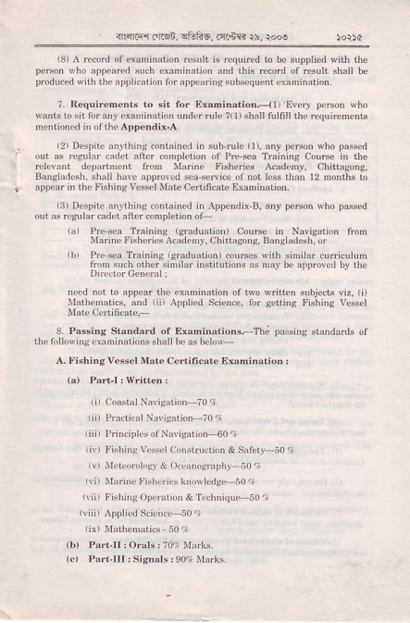
i.ffirrrin T-tf6. ry.€q {5. roo!
i3) A rorr of\amination ro Li is ,rqrned b bc suppried Niih the p..n,' ,\ho ^{qr,.a.cil} $,rh c\3nrn,alnin .nd iliis 'aco ol rcsull shall b€ ,rrHi|g {b3.qu.n1 r:annnitnrn
xx! prrsoD \ho
^{n srb{ulc d). anJ} _{DcrioD} Fho passed
rrod rra.iir rishc.n\ Ac !:mr. chilhpns,
Rigl{l(51,. shrl l,rrc nDrofed srx senr(e oJ not
e co tirL.!! rtr.i,;rarion
n lDqxli\.B, ^{a.y} _{Pc^on} {ho passed
{n as r$lrr.d!! dtcr.on,Dl.t on 0l
inrion5.--Thi ^{prlsins} {andrds or
rhr ri,lrD!ingr\rnrtn{n,ns shaI bcrs helon
A. ri\h,ngv.\!r M01.. !rriti
nr !isrnn! !..r,r( drJnrdnn & s rft( io':
^{'fi} _{rrnri,r rr J G i.x^ndc.-i0} /r
^{(b)} r'ntr ll:orrls:71,', \Ir.kr
^{(c)} I'ari lll 'sisnrk,90'. urks
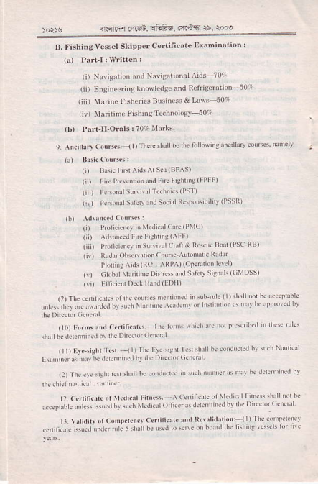
45Trr .!16i _{lfuf{..6dT.} 'h. )ooo
B, f'shing v.srl skipperCedific!rc EMniniion {a) PuiJ: $ritlcn:
ti) NNi! _{io. and Navigrtionrl} Aid-70';
tiiJ Ensineorinskno$lcdse and R.friscmtion t0-' tiii I arinc Fishe 6 ttrsines & I-'wF50?
_{riv) Mnriiiaelish,neTe.hnologv} s0t;
(b) Paft-ll.onls:70+It3rks.
_{e Ai.irrrry0'uBc.-<l)Theft} si'r
(!) B!5j(cuuds:
_{rn} D's ! Fifr^Lds ^' s0(BFAS)
_{rii)} rncPrt!. iNlidfneFshti'i!IFPFF)
⁽ _{t r!6oml} smn!lr€clrii\{Psr)
_{{i\)} PGrtul stLlcrv uirSsil R*romibililv{l'ssn) _{t )} Pmricicrcr _{n[kdnarcoe(Pt} c)
(L) ^d\ sd r t]iighiiql^|l|)
_{.\o'dsod(Psc} RB)
^{(i!} _{) RL'ds oh\d$rioi} .r!^r Inomdi. Rrdrr rro(i'is^id\(Rc _{ARP^)(q!turei} de )
_{{r)} . otrLl [lidritu DirF* d]d sr
_{1\} i) l'tlj.le Dsk rhM(EDH)
_{{r)} n'! cn, ici.i ollrN lqn $ ns
*r*. 'ri"r ,*:^..t",rt, *.t' u-r
.,".' ,,..t ,,r 'ilr ,"i -'.d'
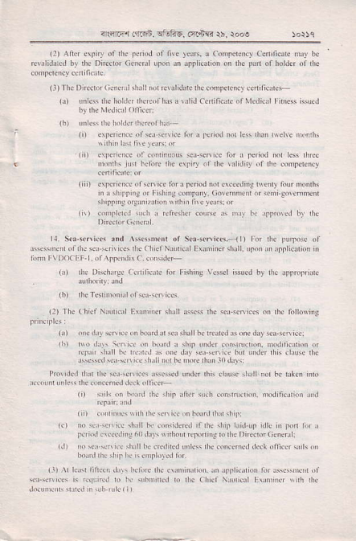
? ^{.cr.i} frrFn. TfstsG. ftiYr ri, rooo
_{tr)} ^{At.i crriry 0f rlr} _{|.fod} or fiv
(r),,ir4s,rc rDrdrr! &,f his r 1
hr _{the Nrsdii} (ni.{:
(b) r N{*r rrr hollis 'rtrrcd hu,+
^{nd i\} _{nN} h.rn thr doiry or rh. !!ri,Jii of _{rk} qnndeily ( ill) e\l{ri.ilt or{^icr tdrr psidn
( r) loqu ldr I criesher cou
^{roi rrit} _{rlrrmc} ot
_{G)} i,c Di{hrsr lLnli6tr lnr F
(rt'h!rsbnonr.'roi5$\!En*.
r1) s.,h !n ho,,'l 'l'!.lrir Jrln \!rh (n{ndrcn. D{riliarior ,nd
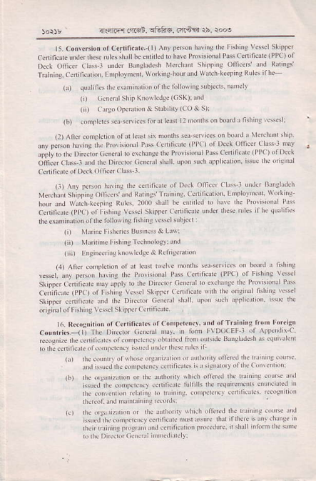
_{)o$r} ' arlqEqi i'r.qn ctr€F, oins rb. rooe
r5.con\c ioD r. c.nificrtel |) An
rirldrd hr* Pm*idn!L _{Pa$ ceniricd.} (PPc) ol
slimi't3 ofier' lid Riingr
rninii!.ceniricdior,Enfloym$(\vo'u-houraidwr.h-reeniisRisf 6+ (r) qu _{ilisft.iunLndiLD} orrrF rbrlo\tiosibj{ts. rundv
_{(i)} (i.ienlshipKiovrsdgc(csK)rt
(li) ci'soonrB,ioi _{& stbiiry} (ao&s)i
(6) .oi,prcts s*enic6 for d hr
(?) ^nercoNPhrion 0Id bln:; no
_{*i".,h.D'..b} {'*.r.".
dft-' ch"r -d d" Di"dd G*rursrurl. upon scr nllhcdidi. hse rN ori{NL
(:) ^{Any} _{ltMi} rH\iB rlt *d,icr. orD{k orfier CL!.'r u i na'slldeh _{Nlerhd sh} ^{p} _{e} otnlsr rid Rr n$r rruinhg caniticnidi EDllovB4 wd*hg |rcfanJ\\,fthkccohgRo$']0ll
_{ceniriat} (Pl,c) offnhiis vesr s
_{rlctrrnin{iononh.} turrGi'g'kliiig E$dsrbj.d:
(i) r1!iR flshdtrs Bunnlss& Lr\Yi
(i') Nhriri'E hshirsrehiology: md
(iii) !'l!i're.rio,q Lnou hdse & R.lji8idriotr
(1) Arier lonplcrioi of ar L.*r rtlv. nodhs ar snt6 on hd'd I fthm3
c.ni6qk IPPO orFi+in! vesrlsklm$ csriridc \ dEorghr nsl'ins E$d _{diginrl otFishi'tg} \tsd sLirrdccnifi .ii
cmrtrie5:lr _{Thc} hni rvDocEF-r ^{of} _{&r} 'dnc ^{b,i."1rrtur} _{"f} ^{--,--.r"q} "".1
t rrrro i'! rltrlri oiared i rimns u$L lid
iinre,!thicdniidgrcyeii|i(l.nsl
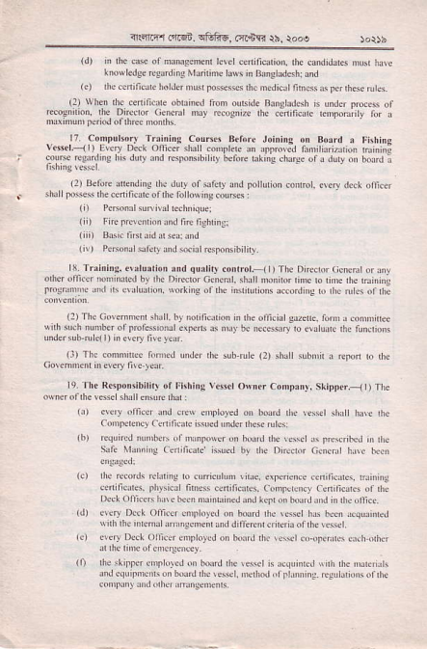
iln ir fr.6n. !i.iiF, rird{i r5, rooe
^{(r)} i if !N oioxlccndr rdcllfbjic,tror. rrr.urd,Jj$ Nn t.o! G) r r lu'iiirr! 60 rd 'nnrio$.
. rr con'pd!,t)
(r) ri r!rr$urif rnt[rc ]ighrhj.
_{l'} ''' ' '' ' o''Ej ''' :
_{{:r nr!} ^{(n,snn!!.r.ir.} [r rdinrr
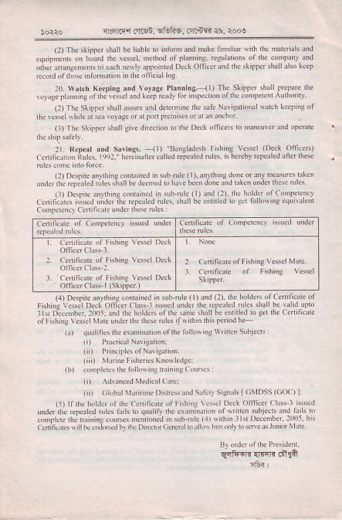
_{1l.r...,r frFn,} ^{qtutg.} .i,6n rb. ro.e
1l) Tr {lrrs Jitllbe hrhLr tr' info
2r) 1\rd, K(phBaid \o)rs. Plrnri* _{rr)nr} Skrm{ shirrForc sL (lrTr ^{sr} _{mu} n'JlLsntre rddo
r ts.Dul ^{rnd s!ris..} ll)
.ddr!.rri iirk!. _{|+)r. i{!} ^{jrun(} drLd rei.,rd _{rub. i\ rmbv} q.r.d ri( 'h6c
^{(driiirr$} \\urd ri'( u rherc,!ild orc arN r(srimq )
^{jd( (rrutr} 1:) rrtr hirsof(rnruuirl
^{]]trD!c!nh{rDr:Ul]tjoL]g|ruk'} _{I\} 6'r 'fnFiod i.-
rafs,srr! riMDss(n{ ⁾ l
r L! $dnr d 0rMh n,hitdr ri riis ii
mNrrd! {,; t,i,,i,'g.u 13 ''sr on
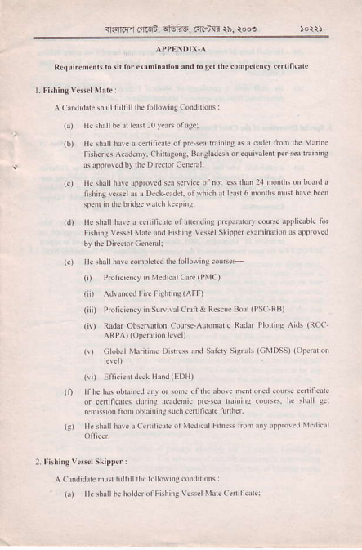
_{3ro&fi.'nirn.} ^{qBF6,} ar.6R ib. ro@
_{G)} ^{rlcshillbcd k!(r0} _{'d*of} rgei
(b) trr \tuir hlYc i .en fist orprc
r rppro{J br rh. Dt-ror csHtrli
_{G)} rlrshrlh!v.Jlpovcdsr$a
_{ld)} He shrllh$e r ccnrticd{ or!
_{G)} ll. slmLlhi!! coflrLdql rh. rb loNii!couRF
(,) Pi[.i.my ir Mcdiurcd(PMc)
_{I} i) ^dumci fn Fighriig(ArF)
( li) Pmri.ir!.} itr suNivll cnfi & Re$uc Bo!(PSc'RB)
(iy) Rrd.i obseFdion cor+ _{A(o'iarn Rrhr Plolns,\n[} (Roc ARPA ) _{lotjsd,oi} l!!d)
^{rfdr s} _{snLLrs} (oMDssr{oD!ru,o,
(!D rnicB ^{dld r!,J} rllDll)
(0 rr|t hls ob1irtr.d _{u,r} ^{q} \ddr o
or .enLfic!'cs ^{ddng trd.n,c} Pre.
1|) ft n'x lb. holdqolFrhitrg vL
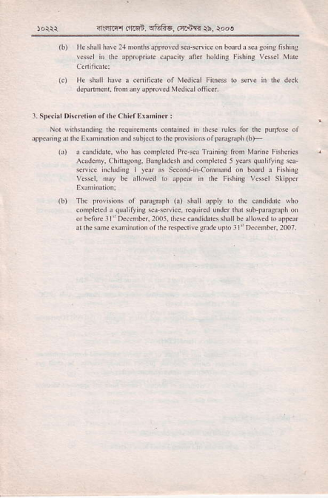
<qFn anqi rfi1i6, @nY. )h, :ooe
od,ii<d[6$ru|a|orftru{'d{df
.pntu iie.r,he Es fdion drbj
_{td} i Q!,ri,r.i., \!rD h6 $nprdld
dsnr|d.d5yeJsqm|'yii!*!
(b) ^{rhr} _{rtuwisid} ^{of} llJngi{fi _{G)} !h!rl
srydedJq!J||yn!sdsce,e
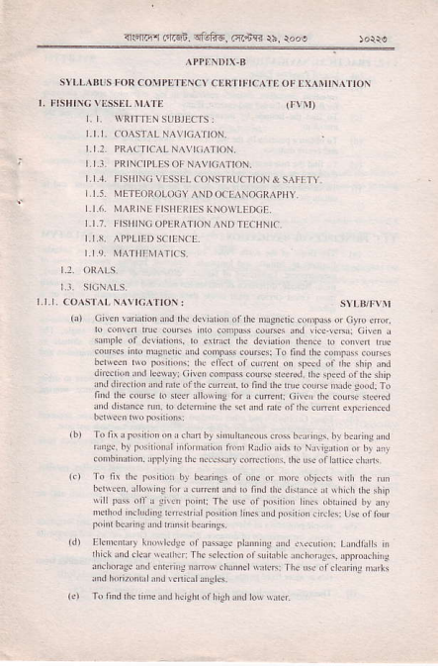
{.niq' _{6r..r} ^{qfrFr.4dq} rh. r.,,
u\5: ro hrd rN &fl].\ r.{r!6
[\ r.trirlt d or f Dd! iLiildi $ rr] rrr! ,ur
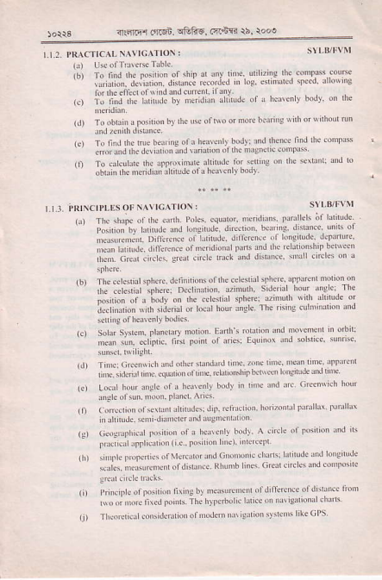
_{atm fri5n. f,1iF6.} (fl+r' 15, root
,.,,,,u1'
B\i,rn of tr iioJv dt 'hc
^{i,.ar'"ri""} " ,t, ..t.rt- t".,,t ru,
,'','''''|,'.'',.I
ra _{Llcr} hqr.rri! rr I ltsurll
_{(r)} ⁽ sr(ri, d:$r.n rtrrLlq r
^. .i '-" rn",r _{r'} *
_{li)} Tr,u(L aL!r\irn on ofNq
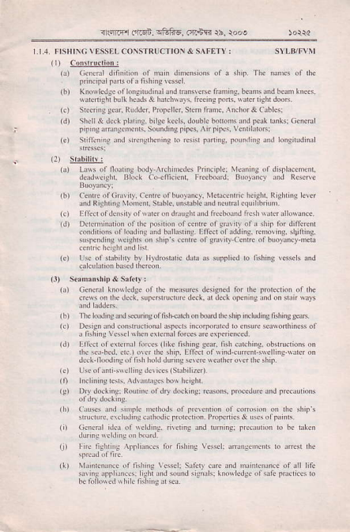
n.drPr _{rr6i} ^{iftlid} ftns r\. ro,e
^{(r)} !_9!r.:!!!s!lt!!
1t ^{srsrir3} _{s!tr.} Raidq. r'oFr{
_{1c) s'ird,rj ud nN,!'h(,ns tr} (
_{r} (lr shbiri*
rr(' o &ri! e sns.,hriig.
_{Gr} cdiciil kN.dgr dj 'h. ft.
i:imr!5rci. rl5ftu Rim _{rh.} )ooe
ldlor 10r!.id,rRs('ioihdr _{hsnrri..ri'l} lotrl|frr rrmnohso
{:n fr- _{rrrn} ^{r,'-F5.} Ffm ri. r. oo
_{lr)} rir, H$drinc 3nd srnrN.:
ro\ {0\Jg. (ri!nrNoir ho\u). .
,., , ,. , ,i. r,,,,,. .,.,,
| 'rirrNr, ^{rl P' I N \lltf!} L\llrLI
r) Inrn,s(i(!r rid ^{\ricrii5} |
+.iF{ _{alrd!.} q&fiF. ^{(rrnin} th. roos
',."..,i. r.,t.", .
otrdt)t3'ifLP'n(ipr'J*'gMg'
_{rclecrouid} q,€.fish brslnNlins {
chain.*ne.oP*&dbEs
Definiridi oI fishins nerhod, dcm.nE ot fishiig ndhod. ndhoas or fii Fkhlnclletiod in theliehtdf I'rrvdrinc
_{ch0hFTovcd} cMr Fishins Mdho
hclh _{hwrins.nid} ^{qarer} rd{lir! Pr
Disdgtrhcc of {di
PuBesi;. ciLneF. sd nds. rrus. ^{b}s ir 'rr. Brv of Bssr; Mrior ri:his c.nsil Lnd*l.dse rbour _{HAccP} (H@rd Analsk conftl Criri'rl Poii0
rhod prcoln bv ^{quesion on rhe} oruri'rl
,pprnrDi ^{drthos} _{nrinc'nres.painlhnv} ii iNrum.nG _{orsvstft} n Ger sr ^{pincilks Brhs rlff ro} _{riiodrce} lomr
(r) (a) M!6ua'nem ol h3ii rhsn
(b) Proprdies ^{of} ,$sr
_{r?)} (r) _{LNsotKthdinprinL} mim( rctrhg niimi sph*icrlmiroi
(b) Lr$sorrefc'id4 lndex of kn
^{cnss: r} _{snpbhrlttlhtDiorrh€} fom
_{rR:n.q!l.'l|B.} ^{qfufiE.} .crnR rb. rooe
(b) ErT.dofliid$d rc'np.nlurc on
' , ^{Rrre ror.lc'oe} _{"nd} Dorr.,.r-l
(4) (i) Theory of nrgndis'n. rals ol magnA;m Im.ftiry of md8nerk on, _{D.llMbilhy,} Ere iviry, hysreresis cn( for fercrogn ric hddial (b) Pol. rugrh, tield ercisrl', Mrg
k) T.mdnl rosftrir'i $d n,sidi
⁽⁵⁾ _{c)} rlrendursors.r(tid.rr
omnc rcrftd ckckic and malr€ri. fi€ld, cartrlhc
(b) Hcding er-r or, .!treNi p.!
_{.f!cK.} ps$s.or.unedrhtuqha.oidud ns$lurjor
_{G)} PrinDry nd icondry rf $ Bdcies.
(d) Axemdins _{vohrs6 rreqamy md} ^{ph} e
Pdwdissipdion,R.$mrce&dRdihcdDi
(c) sinirle,.c. iid d.. cn ui6 Fus
^{MoroB. odrine of srrirbo d} F{i
⁽⁶⁾ Corc.pt ot cldtsmrendic mdrtior and rh. nled for a hith tcqd.i.y orier
(?r (i) cordoi, !nio! bdLtrn dissiiiilr ndrls.
lb) coi$Nion. indu{'r u lFil
(c) ^{FiE *riiNfhiig} _{no!dd,} ^{r.rf. ,ndr} si*s
_{G)} tufilirioir riJ pm.ess. Thory of inricas. Sihpl. ^{.qnrions.} rtobs$ FrroB Sinultntols dqurios
rh! soluionof rrr.quld ri..qurridi. p
' aitl polar co.ordinrti coiitlcrion
. _{rm,. i<ct} f,6F6, _{c4$'B} rh. 5oo,
_{lgr} .di'f.trior rnr Eni, oD d l
rr,'\\!-L_!r i _{r.P 'f\} ^{(F\} \NLN
_{TqFr.ci,} ^{qtuliE,} .46R rr, rooo
l1) ⁶ _{lrs5:} !5cofMrsnqic conrpN.Adorildr
⁽⁵⁾ Lel'd riE: Nl.ikrn! rid Kcdfodfrn ttid tine.
(6) ^{Irnd} _{eofr*srr:P'lnr} orforgedngo s\uy: ! rors idc qurys. ^{jetr} hr, ofDtulcl.^ on rtu {<nog or finjiis
irsl,ing v**r. inddhg nnu cir.
(7) D ies of {&h k(ring oiicer r
^{r'} lf) AnchoBnid ib *. rh
^{(s)} A tul rno\r(Jgc orrhe coftDr ]
(r0) ^{Kr:orrd!. or m3} _{Drc{urion\} I
lr:) ^{Dhk*s silirl\} ; ddis and fi
(rr) lst hd Qr of Lif! srMs ^rptilnc6 c$edi aor fthirs vstul ^{(14) Usr drcor'Fir. F} shriisAnntnmes
^{(rt} Kno\.dgroI'l,ciLdccr rpp r
(r6) rhc !!rnm.
LISJLL^BUS TOR \I NALS Fi \^IINATILIN
^{(o} Mo,sc.ode by n!d, rr'nl lrro si\ ^{\!rns} _{|)er} ni'rrc
_{lb)} hrntlorut codeo{signrrs.
⁽²⁾ Us of Rrdio Te q*o,y on borrd
_{n(rnfl (ltr6n,} ^{qfuhF,} a*ft )b, ro@
: FrsHrNc vtssELsxrPPtR.(Fvsl()
2.I2 MARINE FISHERIES BUSINESS& LAW.
2.I.], ENCINEERING KNOWIEDC
2.2. ORALSEXAMINATION
^{,.r.} !B!EE!!!!J!gr!
(!) rhe eMhk MlgBri. fi.|d. Poles a
venkrl Conponenq viihtior lid
(b) ro fild rh. M{netic Bearirs or Dhbd obnd from coipis B{rins
_{G)} Tie r.llioiship beNe.n rhc Tide
(d) The ituntrhrion and us. or NNi$rion'l
_{G)} voy's. Plrniiryofr Fnlig vs$|.
(i calcullridis .tr
_{lg)} Fmm d ob$Mrion of rny i.rlenly body ie'r I hc mt'idim, ro fi nd thc _{didrionorrh.pcrion} lii. ^{(PrL)rd posiioi dimughvhich ir} B$* (h) ^{Toohtiir} _{I'osirior} by NjiBli'i
(i) crrcirclee liiscoi,Posirec
(r) chromne'er-Lr*sdc eorm
(b) Betrii! iirtu'i.ns
rRi]rrr of.qn. cFFr. dr.iir i|' ro@
k) s.rbn' Priicipl.s or op$dion
(d) Masmriconpass .--Us iid.
non inrsneric roGnit ,id rhrt cllft
.ompNs rnd pffri$l llnirdlo* drmsn ric compaj
_{k)} cym compAs :-4)mssp€, Principlls or rr.. gyr6cqi. Tih ind dri[ prcesion, orhl and dlnpi4 : ^{Con}u$andc0ieofdifferctypso|
^{(t} _{rh.} pnicipk 3nd Applidtion of
_{abbal PG 'ion sysem} (aPs).
_{{!)} Kno$hdc. or .onmon aftid.vib. Kno{hds.
o Sounder. Radio DiEdion Find{.
(b) P.im!ry kno{hdge oi 'h. iole or uN oa.nia'iom like IMo, llq FAo
_{k)} sinpl. kmwkdg. abor llo .o
^{Fkh.min} _{G{ch as cowe} ^{jon} Nos. r12,llr. r14 r25,126)
(d) Kiowledse on rhe chapreB on Fr
.onv.nion on rh. riN of ri? sa
Ecoiomnzoi...bdin.nbrshdr'co |a|
(.) Kidwl.dle ibour
cod.x, stnd.rd tlo.umenb of co.lq, Sp€cialisr
⁽¹⁾ ltrterndbi'r c'iv.nrion. :
(n) Kno\k4e or htmdiorol Mln
€ _{I'ad} ro rh. rorrowinssubj.ds:
lb) Ccnirish$d drhft docnmeib rc
\rsd hy i codioidl .diYe i6$, h
_{r{iodorft.nhsrl} !3lidiry
_{4sF r.'ftnE.} ^{q6l?5.} ft6m rb. rooo
1c) R*NFibii'i* umlg
_{l, !.nri on.i} ^{qrLo} _{tr!i r Lr(} \rtu, ^{!l1ll!} _{!5!} rrrr.
oDiliiqi fLn rrr! Pr'$,loi ortuh
(0 Mrrirr,! Drdtuimol Edn r
(l KBr\rlJcr LL|'r r Plrjo. B!ir'l
_{19 KftN} ^{qls! rbo sL,'D} { coi
Blk ol (\dDrg|
(0 Ki i!Js..'boL r Ilflinc L]!i.l
_{l!)} Kp.hd!. $(d Nrrj"r
rlr) ^{KDo\} _{s!oft!ldl];..} Pilfu+ Dart(
(d Nrd\ &1g! or
_{lb)} ^{(mldsr} _{o,} (rNnmfor & _{Qliiri} luird _{lc)} ^{(iou,ki!.} o, Msrchii shPr!n
_{- -J.l@ 4nrsd.} ^{qEj?6.} ftiF rh, rooo )otoa Lrr.llilLrrRr\c k\o$ I ED
^{(l)} [nBin{ritreXm}Ldscl
^{(d} Princir e ofmkmr .oDbudnr c
_{1b)} Kio\r.dgeof fid orr sr,jrfl. \dscootingsynem
_{G)} RercNigrnoncdtrsrsrgine.rcdldi@3u
(dt ufd diesrer!ii. ^{roi} _{nunp5} !tr
G) Princip corbdirq; no!iri,s.orr,orter
(i) Kio\rr.ds. on Nron & hYd!
(g) Kio\ edsc :hdd ftc righr n,e rnl
ih) wdingrrnpreornctdis5rnLn
1n Birrg.co rcrd NhiEfgir.
_{G)} ^{compresor} I ^{Pr ic,} _{d.} or rfir3.E tron.
_{lb)} Noneof Eftigrrisid 60rrmp.ni.s.
_{k)} r hs v$sd Rlffgfldioi Pr.rl
(r) tsnr sodt& E iroin'(d I
Iril|r Bodr, Fnr Rdrrnl. ^'{ oa ri
^{crss i.r m of [,hhs} _{]rrd'ids} Nri
!h!ds; obn(.r (idr I &
{rifirilr) b rishdgrnd nn hrs.r
^{qfl!-} r{58. _{?lotu4} (rtJs rs, rooe
_{th)} ronsrrcil ^{[+iis} _{!€fB} or1h. \
tr. Tr!\n boii (0tr9 bdrd)
({) c0N$ i6i & sri'riPn or Prtsvlrioi I
^{i.} .. . .. ..i.
(i) rkhab tkn4€nt ,nd rrl
₀ rlsnrB.ntri :
fu i! h!ri,i! ^{r,ir} !
{:rRc'r rr"rn, rEftF Fr{e )., )ooe
_{k)} world FLhins R6oures: Mn
(r) ^{syltrbL(corued} rh{ofu ^{serlirirronorhshfs!$s} Njn{1FvM)
(r) ^{Lrrreuvdr!} rtE ri$d driig ,j
(5) M!! ^{.$,bad} [dnir{
⁽⁷¹ l\datr b ^{ft bro} _{Dfor} ^{ro} _{somd} ig. di.r
(9) rl* rg +drrtlr ig bkl\arqo jno!d[]
^{(r0l} Ad'oi ro bc hk€i ^{$hs} x \<
⁽ r) rho rsgitrsd iish n! \$di RurjL,ry !dd{
^{(r:)} diotr ro hc ^{(orN} !(o rrc ro rrt "Ad ir .6r r dud. iiiLtrx ir. 'i)K'''c'Jd'iuj
_{<rr46,i.!r.6i,} ^{qFfis,} cfttam rb, r..e
FONMS ^ND CERNTICATES RFA!
PA6E'I
^{.S} REPUBI,IC OF AANCLADESH
_{illirfi ot*,} ^{qEfir,} firt{d ti, to@
CDCrPssp.n No. :
r'rhihdidlEis.lisiblrlieibhbb[!rt EsiMuon$lbjdbit |onNi'Eoidinm L H. trr.ds h do rrl Ancilli.ry Cou6a
shieTfishingv6.|fo'.'.'.'''.'.'.'''''funlrBb.|orc
isBrc orhb enifi€b of Cm!tu.y.
^{qlnifl} _{atd.} ^{q&fia,} ari..irr ri, to@
PAGEI FVDOCEF.2
MINISTRYOF SHIPPING
DEPARTMENT OF SHIPPING
FISHINC VESSEL M^IT?SIIPPER
_{ir9riqi diEn.} ^{qtuh6.} mim rh. rd.o
d^tnnn.r olttt Pdtrn.\ Rtprbh. aJoa'xLd(r
b\r8 i!rchN dlhe $! s spdned. lLbjed b
LINIITITLONS^PPLYINC'J S '
LrMrr^r, rNs ArfLr rNa ^{(ifiJ} I
rl.{.n!fl ot$, ctrfi6, .fdffr ri, rooe
Th! DeFdm.nr of shippins, covenn.d of Binskdesh, hs.by a[o$ I . v.*d _{b $r1 f.r a} ^{p.nod} _{ol 12} ^{(rvd()} modhs ryirh $. followins conpl.m.nc :-
r. Navisarionr I warch _{k(pins oficer} ^{(Aaordiis} ro rMo convenrion sTc w ( F).gJ
6 [igiierw''chkdpiigom.ff(artodiitror ocoivrflioisrcw(F)e5 3. ElsicRihg.
(ChnlN ricalsur€rot
irqrihr _{alFn.} ^{q686.} rq.+{r rb
c!ni6ci. isrcd undo rlEpiovkioN
ald rie sTcw (Ffrtt5coiuridn
ll:::l:*:::i:'""'": ::*:l'lTl*l::l :::ll":
^{dlnce \nh di} _{rrcvkioN} otrcsutarion......... ot
od co'npd.ir b pdfdn 6c lblloving |undioB,
{ 'rid hrksndfid. $bj.d b sy ri'nirdioN Lndicared lirirr....... .. d uirirrrhe dde L|M T4T|oN! APPL\ |Nallilj)
hindriis iid no*lgc. cddroning
LrMIT4TLoN APPLYINa l l!n,
_{<R'fl.fi cn} ^{q!. qftfiF.} nin{r \b, {oN
\hctrby rli. ritrLd,le $ ird fos(ry- or rltnr on ol $n do.d'ne could con\lirft ! Any p.mn orh.r rhln ^{rh. lolds coD,i'E in} _{lross$ion} or rhh dod'med n rcluttd ro
sid ir to th. Dftdor ceienl. D.nl
I bY rhc Jdd'€see
^{,nfi.'d (i!en,qGfi6,} cq.ns $, {ooe )ot8d,)orco
The oi8iirl ol rbis
tgularioi......... ..paruEF0h .......ofrh..oiv.nrioi whik $ninsonbomd!shln.
}jr.orbinhofri.hoids
Pl,e orbinh of rh. horder............................................ _{aM[{yiis} condi'ions m.' on.
cehifi cdre is$ed DEPARTMENT OF SHlPPlNc, DHAKA BANcIIDESH.
'Eh''d(-.' --^^''-
]cm*'f
_{d ft ffi} ^{(5inr} _{Gr} fi). Gr fiF,3rqfi ^{nrdn} _{srB.} ^{lr+r {f.} _{rGs} L _{fl:} ^{q'Fi} _{eiia} ^{qm.} .q-6m. nsr61 _{w €} qrtir qiin.
@ir€- tFr -6. fqft!

